Coastline Flight Training

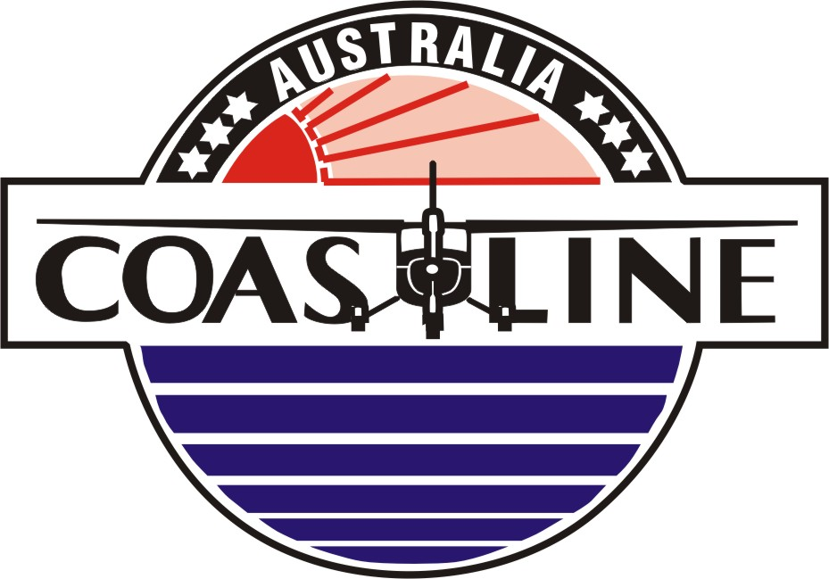

Cessna 172 R

Detailed Checklist

12 Pathfinder Drive
Caloundra Airport Qld 4551

Ph: 1800 072 118
(+61 7) 5491 8588
Web: www.chopperline.com
www.coastlineaviation.com.au
Email: info@chopperline.com
Checklist Use
The Pilot Operating Handbook is the primary reference and if any discrepancies exist between the Pilot Operating Handbook and this checklist, the Pilot Operating Handbook information takes precedence. The Chief Flight Instructor is to be notified immediately if any discrepancy is found so that the appropriate amendment(s) to the checklist can be made. There are two methods for checklist use...
- DO & CHECK
- READ & DO
This detailed checklist is primarily to be used as a READ & DO checklist.
Some normal & emergency checklist actions are required to be completed in a timely fashion.
These checklists are memory checks.

Memory checks are marked by a box and have bold type in their entirety.

***** Indicates particular checks are complete

At all times:
AVIATE Fly the Aircraft
NAVIGATE Position the Aircraft
COMMUNICATE Radio & Brief
ADMINISTRATE Checklist Action

Hand Over Procedures:
“HANDING OVER ......... Taking Over”
“I HAVE CONTROL ........ You have control”

CAUTION: DUE TO VIS RESTRICTIONS FM THR RWY 12 & 23, PILOTS ARE TO ENSURE NO CONFLICT EXISTS PRIOR TO TKOF.

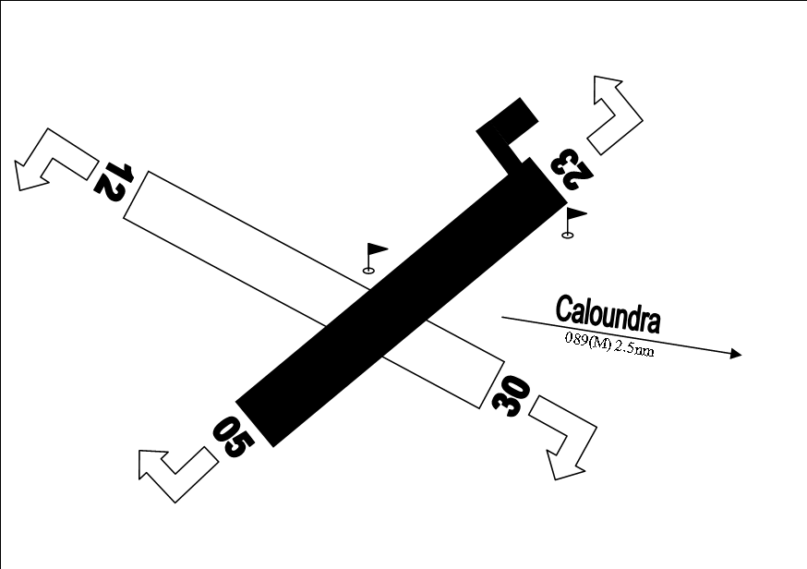
YCDR CTAF 118.8 BN FIS 129.0
YCDR PAL 119.6 BN RADAR 125.7
BN FLIGHTWATCH 128.75
YBMC ground 121.1
YBMC tower 124.4
YBMC ATIS 119.8 / 114.2
YBMC AWIB 119.8
MC VOR 114.2
MC NDB 380 (M _ _ C _ . _ . )
YBMC PAL/AFRU 124.4
CENSAR 1800 814 931
Maroochy Tower – 07 5448 7662
Maroochy AWIB – 07 5450 6032 or 119.8
Brisbane ATS unit – 07 3866 3588 (slot time)
Brisbane ATS unit – 07 3866 3694 (IAL)

Pilot Recency Checks/Personal Minimums - Complete
PRE START

Pre flight inspection ( refer POH + AWB/AAC) Complete
Maintenance Release Checked, complete & on board
POH/GNSS Manual On board
PAX brief Complete
ATIS/ AWIB Received
Clock (Aircraft &/or Pilot) Checked
Assigned Altitude Indicator Set
Altimeter(s) (VFR +/- 100ft) (IFR +/- 60ft) QNH Set & Cross Check
Transponder Standby & Code Set
Take Off Safety Brief (Pilot – Pilot) Given
Departure Brief (VFR “Visual”) (IFR/SID SRD Plate) Given
Approach Brief (VFR: Not Applicable) (IFR: Plates) Given
Seats Adjusted & Locked
Seat belts/Harnesses On & Adjusted
Brakes Tested & Set ON
Fuel Selector Valve Both
Fuel Shut Off Valve ON, Push Full IN
Alternate Static Source OFF / IN
Mixture ICO- Idle Cut Off, Pull Full OUT
Throttle Open ¼ inch/5mm
Panel Lights/ Bright Dim Switch Set
Avionics Master Switch OFF
Nav Lights As required, ON
Electrical Equipment (switches, Landing/Taxi lights) OFF
Flashing Beacon ON
Circuit Breakers Checked IN
Avionics Circuit Breakers Checked IN
Master Switch ON
T’s & P’s ( COLD or HOT Start) Checked

*****

Cold Start

Aux Fuel Pump Switch ON
Mixture Full Rich (Full forward)
Suitable fuel flow (3-5 seconds)
ICO-Idle Cut OFF (Full Aft)
Aux Fuel Pump Switch OFF
Propeller Area Clear “Clear PROP”/3xflash LDG light @ night
Ignition Switch (Key) Start
Mixture Advance (when engine starts)
*****

Hot Start

Propeller Area Clear “Clear PROP”/3xflash LDG light @ night
Ignition Switch (Key) Start
Mixture Advance (when engine starts)
*****

After Start
Oil Pressure Check/Rising
Alternator/Ammeter Checked
Instrument Air (Suction/Vacuum) Checked
Avionics Master Switch ON
Panel Lights/ Bright Dim Switch Not required OR Set
Intercom Set & Checked
Marker Beacons Tested & Set LO
Radios ON/Volume Checked & Set
Navaids Set & Identified
Transponder Code Set & Standby
Flaps Retract
Taxi Light ON
AI/AH Erect & Pitch Bar Set
DG/DI (HSI) Checked/Aligned
ATIS/AWIB Received
Taxi Call Complete
Park Brake OFF
*****

Taxi

Brakes Checked
Rudder Checked
Flight Instruments & Navaids (Function) Checked
*****

Run Up

Park Brake Set/ON
Clear Behind Check
Engine Instruments (T’s & P’s) Checked
Throttle Set 1800RPM
Magnetos Check
“Right Actual ___” “Left Actual ___” “Differential ___”
Vacuum/Suction Checked
Ammeter Checked
Annunciator Panel “Test” Checked - Not illuminated
Throttle Check Idle “Actual ___”
Throttle Set 1000RPM
Throttle Friction Lock Adjust/Set

*****

Pre Take Off

Passenger Seat Backs Most Upright
Seats & Seat Belts Check Secure
Cabin Doors Closed & Locked
Fuel Quantity (Gauges) Checked
Flight Controls Free & Correct
Flight Instruments Set & Checked
Heading Bug Runway Heading Set
Nav/GNSS(GPS) Switch (NAV or GPS) Set
GNSS(GPS) ( Verify ON – “ENTER” + Validate) Set
Radios Tuned & Set
NavAids Tuned & Set
Auto Pilot Checked then, OFF
Mixture Rich
Wing Flaps Set (Zero/10 degrees)
Trim Checked
Trim (Take-Off position) Set for Take-Off
Fuel Selector Both
Clearance Received/Not Required
Course Bar/Track Bar (HSI) (if fitted) Set
Brakes Release/OFF
*****
Hold Point

Hatches Closed
Clearance to cross Received/Not required
Lookout (RWY, FINAL, BASE L&R) Complete
*****

Line Up

Transponder Set/ALT
Pitot Heat ON
Strobes ON
Runway Alignment Checked
DI/DG (HSI) Aligned with Compass
Wing Flaps Set (Zero/10 degrees)
Windsock Checked
*****

Take Off
“Clear for Take-Off” Landing Light ON
Heels On the Floor
Throttle Full Open/ Max RPM
T’s & P’s Green
Airspeed Increasing
*****

After Take Off

Brakes Apply
Wing Flaps Retracted
Mixture Full Rich
Throttle Full Open
T’s & P’s Green
*****

Climb

Power (MAX) Set
OAT Checked
Suction/ Vacuum Green
T’s & P’s ( Engine) Checked/Green
Altimeter Checked
*****

Top of Climb

Level Off Assigned Altitude
Auto-Pilot ON
OAT Check
“Revised Freezing Level is..................” (2deg. per 1000ft)
Set ASI OAT & ALT
Cowl Flaps Closed or Not fitted
Set Power Ref. Cruise Table
Mixture Set (9 gph)
Check Fuel Pump OFF
Top of Climb Time Logged
*****
Cruise

Compass Aligned to DG/DI/HSI
Correct Heading
Log Complete/Not Required
Engine T’s & P’s Green/Power Set
Mixture Leaned
Altimetry Checked QNH/Cruise Level
Radio Set/Call/Transponder Code
Orientation Checked
Fuel Sufficient/Appropriate tank/Log Complete
Forced Landing Select Field
*****

Pre - Manoeuvre

Height Sufficient to recover by 3000ft AGL
Airframe Sound & Configured
Security Checked
Engine Checked
Location Suitable
Lookout Complete
*****

Diversion

Details - log Time over known position or DR fix
Identify – confirm position, actual location/fix & Destination
VNC/VTC/ERC- check along new track for P/R/D CTA/CTR
Estimate- Track & Heading, Distance & Time, Endurance
Report- R/T – “Centre-Flightwatch” FPlan amendment details
TAF- divert to aerodrome (TAF, NOTAM, Ops.Procedures)
*****

Top of Descent/ Pre Approach

Compass (DG) Aligned
Altimeter Assigned ALT Set/QNH Set
Aids (incl GNSS) Tuned & Identified
Approach Brief (IFR-Plate) &/or Join Intentions Given
Mixture Full Rich
Radio(s) Set
*****

Pre Landing

Brakes Checked/Heels on floor
Park Brake OFF
Under carriage Fixed/Down
Mixture Full Rich
Fuel Selector Both
Fuel Quantity Checked
Instruments (Engine T’s & P’s) Checked/Green
Switches (Key- Magnetos) Confirm on Both
Carburettor heat Not Fitted
Hatches/Harnesses Secure
Autopilot OFF
Landing light ON
Traffic (Downwind/Base L&R/Final/Runway/Radio) Checked
*****

Finals

Pitch Fixed
Undercarriage Fixed/Down
Flaps Set
Landing Clearance Obtained
Runway Clear
Windsock Checked
*****

After Landing (vacating Runway)

Transponder Standby
Pitot heat OFF
Strobes OFF/As Required
Unnecessary lights (Landing Light) OFF
Flaps Identified & Retracted
Trim Set (Take-Off position) Neutral
SAR (Flight Watch) Cancelled
*****

Shut Down
Throttle 1000RPM
Park Brake Set/ON
Magnetos Check Right/Left
Electrical Switches (Taxi Light) OFF
Avionics Master OFF
Mixture (Pull FULL OUT) ICO - Idle Cut OFF
Nav Lights OFF
Beacon Light ON
Ignition Switch (Key)/Magnetos OFF/Keys Out
Fuel Gauges/Check Quantity
Master Switch OFF
Fuel Tanks Select Right Tank
*****

Vacating Aircraft

Flight Log Complete
Control Lock Set/IN
Throttle/Mixture Locked
Seat Belts Dressed
Fuel Tanks DIP
Doors (Cabin & Baggage) Locked
Air Inlet Bungs Fitted
Propeller Dressed & Secured
Pitot Cover ON
Tie downs ON
Post (After) Flight Inspection/External Checked
*****

Please Note

If you are the Last flight of the day the following applies:

Aircraft Hosed OFF
Aircraft Chamois
Leading Edges Wiped Clean/NO Bugs
Windscreen Chamois
Throttle/Mixture Lock ON
Aircraft Cover ON
Gust Locks Fitted

*****

Information Page Only
Quick Reference Data

Vne 163KIAS
Vno 129KIAS
Va 99KIAS (1111kg) 92KIAS (907kg) 82KIAS (725kg)
Vfe Under 110, Flaps 10
Under 85, Flaps 20,30
Vr 55KIAS
Vs1 44KIAS
Vs0 33KIAS
Vx 60KIAS
Vy 79KIAS
Normal Climb (Take off) 70-80KIAS
Short Field (Take off Flaps 10) 57KIAS
Cruise Climb 75-85KIAS
Landing Approach/Normal (Flaps up) 65-75KIAS
(Flaps 30) 60-70KIAS
Short Field (flaps 30) 62KIAS
Best Glide (Clean) 65KIAS
(Flaps Extended) 60KIAS
Engine
Textron Lycoming IO-360-L2A
Rated Power 160 Bhp rating
Maximum Engine RPM 2400RPM
Oil (sump) Min 5 Max 8 USQ
Oil Pressure Max 115 psi/Idle Min 20 psi
Oil Temperature Max 245$°$F (118$°$C)
Propeller MacCauley 1C235/LFA7570,75”Diameter
Static RPM at full throttle Min 2065-2165RPM
Information Page Only
Fuel
Fuel Grade 100LL Grade Aviation Fuel (Blue)
100 Grade Aviation Fuel (Green)
Total (2 Tanks) (56USG) 212 litres
Useable total (2 Tanks) (53USG) 200 litres
Planned Burn Rate (OM ref: B1-G) (9 USGPH) 34 lph
Endurance: 200 litres at 34 lph – (5hr : 50 mins) 350 mins
Weights

MRW 1114kg (2457lb)
MTOW 1111kg (2450lb)
MLW 1111kg (2450lb)
BEW (see POH for each aircraft) 744kg (1639lb)
Maximum Baggage Area 1 54kg (120lb)
Area 2 22kg (50lb)
Combined Baggage (Area 1 + Area 2) 54kg (120lb)
Airframe
Length 8.28m
Height (Top of Fin) 2.71m
Height (Propeller tip) xx
Propeller Clearance 28.5cm
Wing Span 11.0m
Wing Area 16.17m2
Wing Loading 68.71kg/m2
Tailplane Span 3.45m
Min Turning Radius 8.37m
Power Loading 6.94kg/hp
G limits (load factor) +3.8g/-1.52g (normal)
@ MTOW 2450lbs +3.0g/-0.0g (flaps down)
Information Page Only

Systems

Stall Warning Horn 5~10kts before stall
Landing Gear Nose 5 in, 34psi
Main 6 in, 28psi
Nose Wheel Steering xx$°$ Left & Right
Alternator 28V/60A
Battery 24V/xx Amp hr
Vacuum 4.5’~5.5’ Hg
Starter Duty Cycle 30 sec ON/ 2 min OFF

Circuit

Take Off FULL POWER
Upwind Full Power 70-80KIAS
Crosswind Full Power 70-80KIAS
Downwind 2000-2200RPM/ 90-110KIAS
Base 1500RPM/ 75KIAS
Landing Approach/Normal (flaps up) 1500RPM/ 65-75KIAS
(flaps 30) 1500RPM/ 60-70KIAS
Maximum Crosswind component 15Knots

SLOW & LOW FLIGHT: 2200RPM – flap 20 deg – 80 KIAS
(CAUTION: Max 85 KIAS)

Information Page Only
PAX Brief
CAO 20.11, paragraph14 OM Reference: A4.10

- Smoking h. Dangerous Goods
- Seatbelts i. Operation of Doors
- Emergency Exits j. PAX in control seat
- Oxygen k. Aircraft Fire on ground
- Flotation Devices l. Fire Extinguisher
- Stowage of Hand Luggage m. First Aid Kits
- Special Survival equipment n. PAX Safety Briefing card
o. Climate Control
p. Headset use
q. Comfort (Sick) bags
r. Venues – Destinations
Example Brief:

“Welcome Aboard,
Just like airlines I am obliged to give you an emergency briefing so please pay attention. This is a C172 Aircraft. In the event of an emergency follow my instructions. There is a PAX Safety Briefing Card in the back pocket in each seat, please take time to review it.
The emergency exits are the doors that we enter the aircraft through. They lock and unlock like this (demonstrate). There is a baggage door however that is locked during flight.
The windows can be opened on the ground and they can be open as we taxi for airflow comfort, however we would close them and secure latches before take off.
There is no smoking at any stage on this flight.
Please wear seatbelts during takeoff and landing, or as I direct. I would advise you to keep them on at all times. They operate like this (demonstrate).
Any hand luggage should be in the baggage compartment or secure on the floor.
This aircraft has dual controls (demonstrate control column & rudder). Please be sure NOT to touch the controls at any time.
Fire Extinguisher is located between the front seats and a first-aid kit is located in the baggage compartment.
Oxygen (if not fitted – do NOT mention)
Life jackets, floatation devices and Special Survival Equipment (if not carried do NOT mention)
A portion of the flight will be over water. Life jackets are located behind the seats (or demonstrate how they are put on & worn, around the waist or over the head)
Any questions please don’t hesitate to ask. Thank you & enjoy your flight.”
Information Page Only
Pre take-off safety Brief

Pilot to Pilot Only

“This will be a (normal/ short field) take off.
Flap setting will be (zero/ 10 degrees)
Rotate speed will be 55kts
Climb out speed will be ____kts

Engine failure on the Runway, I will...
- Close throttle & abort the take-off
- Brake
- Stopping on the remaining runway
- Shut down”

Engine failure airborne with SUFFICIENT runway remaining, I will...
- Lower the nose
- Close the throttle
- Land on the remaining runway or overshoot”

Engine failure with INSUFFICIENT runway remaining, I will...
- Lower the nose to the glide attitude
- Select a clear area left or right
- Close the throttle
- Use flaps as required to land in the selected area”

Information Page Only
After Start

Pilot “Intercom Check”
Instructor “Reading 1~5”
PAX “Loud & Clear”

Taxi
Brakes
Pilot Taxiing
- “Brakes Checked, you have control to check brakes” OR “Brakes Checked, handing over for you to check brakes”
Instructor taxiing
- “Brakes checked, you have control”

Flight Instruments & NAVAIDS function check (left & right turn)
- “Turning Left, skidding right, AI Wings level, Compass/DI (DG, HSI) following, Navaid(s) tracking”
- “Turning Right, skidding left, AI Wings level, Compass/DI (DG, HSI) following, Navaid(s) tracking”

Pre Takeoff - Flight Controls – Free & Correct

“Control column Full forward, Full left & Full right.
Full aft (back) Full left & Full right.”
OR
“Control column full forward, elevator trailing edge down, full left, aileron trailing edge up – check left & right, full right, aileron trailing edge up – check right & left.
Control column full aft (back), elevator trailing edge up, full left, aileron trailing edge up – check left & right, full right, aileron trailing edge up – check right & left”

Information Page Only
Pre take off

Flight Instruments Checked Left to Right, Top to Bottom
“Reading Zero, wings level, altimeter set & checked
Flag away/wings level, DI/DG (HSI) aligned with compass, Heading bug set, VSI reading Zero”

Takeoff

- Take off Power Applied
- Heels on the floor
“Max RPM, T’s&P’s Green, Airspeed increasing”

Work Cycles

Attitude Lookout Performance

C&D: Aim Point Attitude Speed
S&L: Aim Point Attitude Height

Finals: Aim Point Aspect Centreline Airspeed

Nav. Turning Points: Wind Heading Altitude Time

Information Page Only
ALA strip length 1 knot = 0.5 metres per second
Example: 80KIAS for 20 seconds : Strip length = 800 metres
100KIAS for 15 seconds : Strip length = 750 metres

Departure Gradient ALA’s ( Estimation method)
GRADIENT 5% = 1:20 (1 in 20)
Place “1 metre high stick” at end of strip and pace back 20 metres sight from ground level over the top of stick to ensure obstacle clearance

Time to PNR (min) = Safe End(min) X GS home
GS home + GS out

Dist to PNR = Time to PNR X GS out
60

Dist to CP (ETP) = Total dist X GS home
GS home + GS on from CP

PH = AD ELEV + 30x(1013 – QNH)

ISA = 15 – (2 X PH/1000)
DH = PH + ((OAT – ISA) X 120)

Information Page Only

International Morse Code

A • ― B ― • • • C ― • ― • D ― • •
E • F • • ― • G ― ― • H • • • •
I • • J • ― ― ― K ― • ― L • ― • •
M ― ― N ― • O ― ― ― P • ― ― •
Q ― ― • ― R • ― • S • • • T ―
U • • ― V • • • ― W • ― ― X ― • • ―
Y ― • ― ― Z ― ― • •

